Given a time in 12[-hour AM/PM format](https://en.wikipedia.org/wiki/12-hour_clock), convert it to military (24-hour) time.

Note: - 12:00:00AM on a 12-hour clock is 00:00:00 on a 24-hour clock.  
- 12:00:00PM on a 12-hour clock is 12:00:00 on a 24-hour clock.

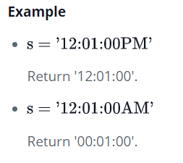

**Function Description**

Complete the *timeConversion* function in the editor below. It should return a new string representing the input time in 24 hour format.

timeConversion has the following parameter(s):

* *string s*: a time in 12 hour format

**Returns**

* *string*: the time in 24 hour format

